Sportsworld at Tiny Hoppers

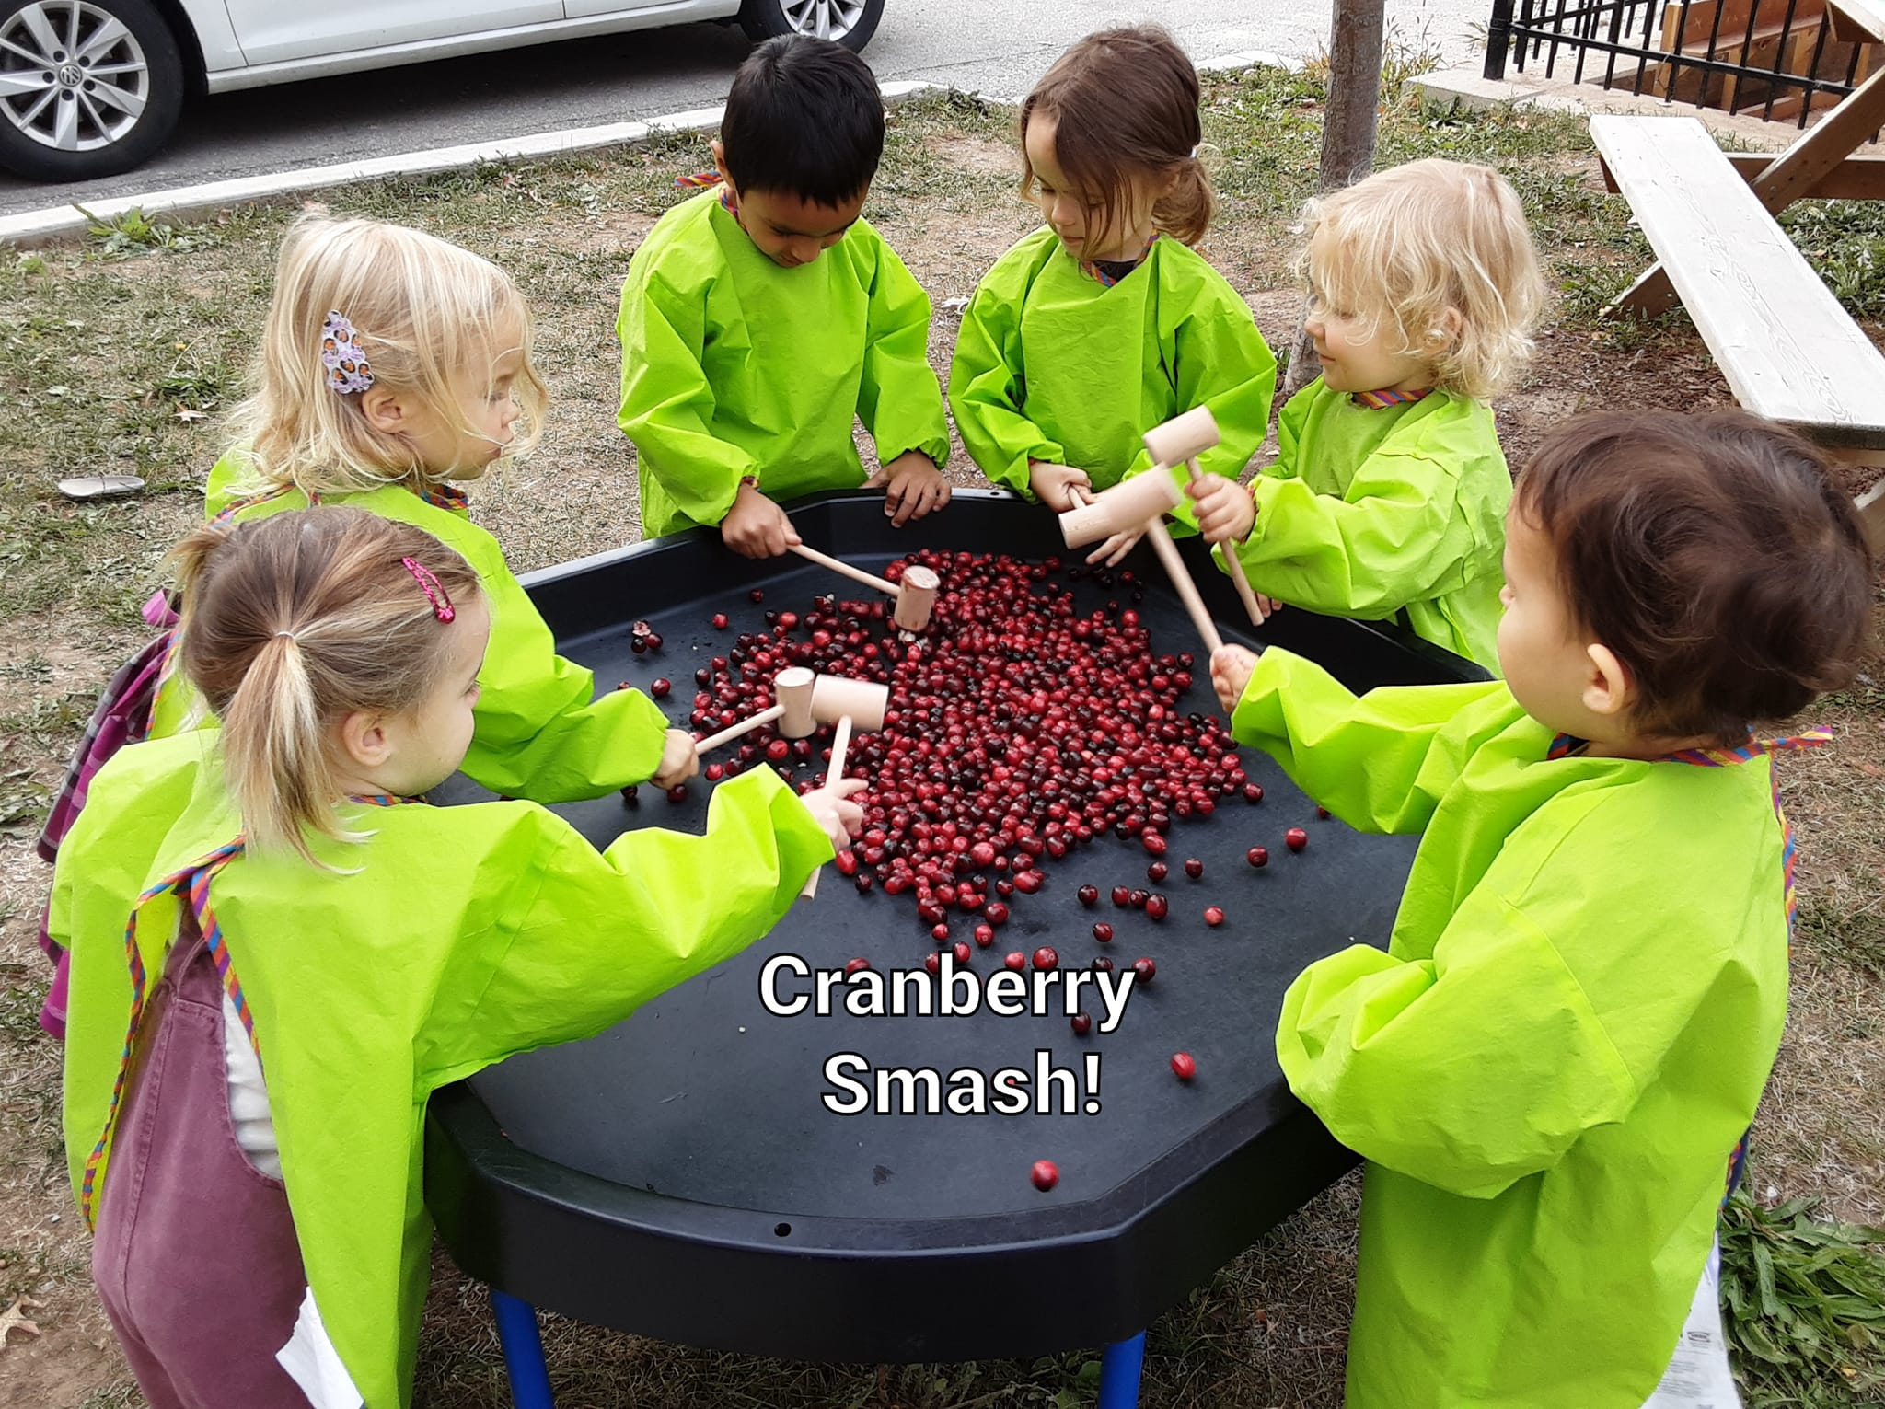

Our preschool classrooms are focusing on our fine and gross motor skills. As you can see in the photo shown above, the preschool classroom is smashing cranberries!

Fine motor skill efficiency significantly influences the quality of the task outcome as well as the speed of task performance. Efficient fine motor skills require a number of independent skills to work together to appropriately manipulate the object or perform the task.

Gross motor skill development involves the large muscles in the arms, legs and torso. Gross motor activities are important to everyday physical activities like walking, running, throwing, lifting, kicking, etc. Gross motor abilities also form the basis for [fine motor skills](https://www.chrichmond.org/therapy-services/occupational-therapy/developmental-milestones/fine-motor-skills-birth-to-2-years) and relate to body awareness, reaction speed, balance and strength.